OCCTO website
The OCCTO website links you to the websites of the individual zonal power companies, and from here we can find the supply and demand data.
https://www.occto.or.jp/keitoujouhou/ (middle of page)
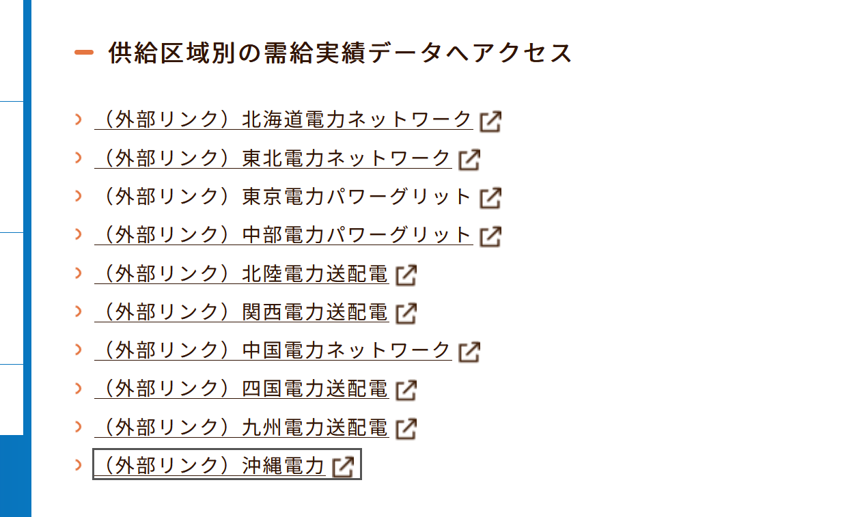
Supply and demand data for 9 zones + Okinawa from the websites of the individual zonal power companies. From top to bottom it is: Hokkaido, Tohoku, Tokyo, Chubu, Hokuriku, Kansai, Chugoku, Shikoku, Kyushu, Okinawa

Data pages:
Note: some pages provide links to CSVs containing electricity consumption data (電力使用) as well. For supply and demand data, you want to look for the characters エリア需給 or 需給
Zone | Link
Hokkaido | https://www.hepco.co.jp/network/con_service/public_document/supply_demand_results/index.html
Tohoku | https://setsuden.nw.tohoku-epco.co.jp/download.html
Tokyo | https://www.tepco.co.jp/forecast/html/area_jukyu-j.html
Chubu | https://powergrid.chuden.co.jp/denkiyoho/
Hokuriku | https://www.rikuden.co.jp/nw/denki-yoho/results_jyukyu.html
Kansai | https://www.kansai-td.co.jp/denkiyoho/area-performance/index.html
Chugoku | https://www.energia.co.jp/nw/jukyuu/eria_jukyu.html
Shikoku | https://www.yonden.co.jp/nw/supply_demand/data_download.html
Kyushu | https://www.kyuden.co.jp/td_area_jukyu/jukyu.html
Okinawa | https://www.okiden.co.jp/business-support/service/supply-and-demand/index.html

Data format:
All the zonal power companies provide their supply and demand data in the same format, as an example:

Below I have included the mappings for each column.
エリア需要 | Area Demand
原子力 | Nuclear
火力(LNG) | Thermal (LNG)
火力(石炭) | Thermal (Coal)
火力(石油) | Thermal (Oil)
火力(その他) | Thermal (Other)
水力 | Hydro
地熱 | Geothermal
バイオマス | Biomass
太陽光発電実績 | Solar
太陽光出力制御量 | Solar curtailment
風力発電実績 | Wind
風力出力制御量 | Wind curtailment
揚水 | Pumped Hydro
蓄電池 | Battery
連系線 | Interconnector
その他 | Other
合計 | Total

